1. ***SQL INNER JOIN Keyword***

* The INNER JOIN keyword selects records that have matching values in both tables.

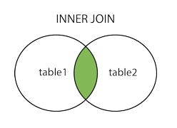

* INNER JOIN Syntax ;
* **SELECT column_name(s)  
  FROM table1  
  INNER JOIN table2ON table1.column_name = table2.column_name;**
* Example-1 (Join two tables) :
* **SELECT Orders.OrderID, Customers.CustomerName  
  FROM Orders  
  INNER JOIN Customers ON Orders.CustomerID = Customers.CustomerID;**
* Example-2 (Join three tables) :
* **SELECT Orders.OrderID, Customers.CustomerName, Shippers.ShipperName  
  FROM ((Orders  
  INNER JOIN Customers ON Orders.CustomerID = Customers.CustomerID)  
  INNER JOIN Shippers ON Orders.ShipperID = Shippers.ShipperID);**

1. ***SQL LEFT JOIN Keyword***

* The LEFT JOIN keyword returns all records from the left table (table1), and the matching records from the right table (table2). The result is 0 records from the right side, if there is no match.

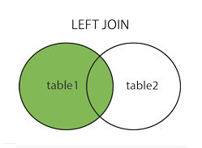

* LEFT JOIN Syntax :
* **SELECT column_name(s)  
  FROM table1  
  LEFT JOIN table2ON table1.column_name = table2.column_name;**
* Example :
* **SELECT Customers.CustomerName, Orders.OrderID  
  FROM Customers  
  LEFT JOIN Orders ON Customers.CustomerID = Orders.CustomerID  
  ORDER BY Customers.CustomerName;**
* Notes :
* The LEFT JOIN keyword returns all records from the left table (Customers), even if there are no matches in the right table (Orders).
* In some databases LEFT JOIN is called LEFT OUTER JOIN.

1. ***SQL RIGHT JOIN Keyword***

* The RIGHT JOIN keyword returns all records from the right table (table2), and the matching records from the left table (table1). The result is 0 records from the left side, if there is no match.

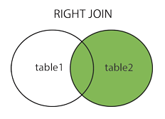

* RIGHT JOIN Syntax :
* **SELECT column_name(s)  
  FROM table1  
  RIGHT JOIN table2ON table1.column_name = table2.column_name;**
* Example :
* **SELECT Orders.OrderID, Employees.LastName, Employees.FirstName  
  FROM Orders  
  RIGHT JOIN Employees ON Orders.EmployeeID = Employees.EmployeeID  
  ORDER BY Orders.OrderID;**
* Notes :
* The RIGHT JOIN keyword returns all records from the right table (Employees), even if there are no matches in the left table (Orders).
* In some databases RIGHT JOIN is called RIGHT OUTER JOIN.

1. ***SQL FULL OUTER JOIN Keyword***

* The FULL OUTER JOIN keyword returns all records when there is a match in left (table1) or right (table2) table records.

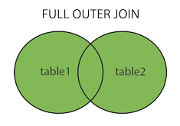

* FULL JOIN Syntax :
* **SELECT column_name(s)  
  FROM table1  
  FULL OUTER JOIN table2ON table1.column_name = table2.column_nameWHERE condition;**
* Example :
* **SELECT Customers.CustomerName, Orders.OrderID  
  FROM Customers  
  FULL OUTER JOIN Orders ON Customers.CustomerID=Orders.CustomerID  
  ORDER BY Customers.CustomerName;**
* Notes :
* The FULL OUTER JOIN keyword returns all matching records from both tables whether the other table matches or not. So, if there are rows in "Customers" that do not have matches in "Orders", or if there are rows in "Orders" that do not have matches in "Customers", those rows will be listed as well.
* FULL OUTER JOIN can potentially return very large result-sets!
* FULL OUTER JOIN and FULL JOIN are the same.

1. ***SQL Self Join***

* A self join is a regular join, but the table is joined with itself.
* SELF Join Syntax :
* SELECT column_name(s)  
  FROM table1 T1, table1 T2  
  WHERE condition;
* Note : T1 and T2 are different table aliases for the same table.
* Example :
* SELECT A.CustomerName AS CustomerName1, B.CustomerName AS CustomerName2, A.City  
  FROM Customers A, Customers B  
  WHERE A.CustomerID <> B.CustomerID  
  AND A.City = B.City  
  ORDER BY A.City;